**Assignment-9 [OOPS Concepts]**

[Submitted by **Malika Hafiza Pasha**]

**Please implement the following in Python**

1. Construct a class which takes in 3 arguments—first name, last name and age. And create an instance of that class.

**Answer:** [Python file is attached with the assignment file]

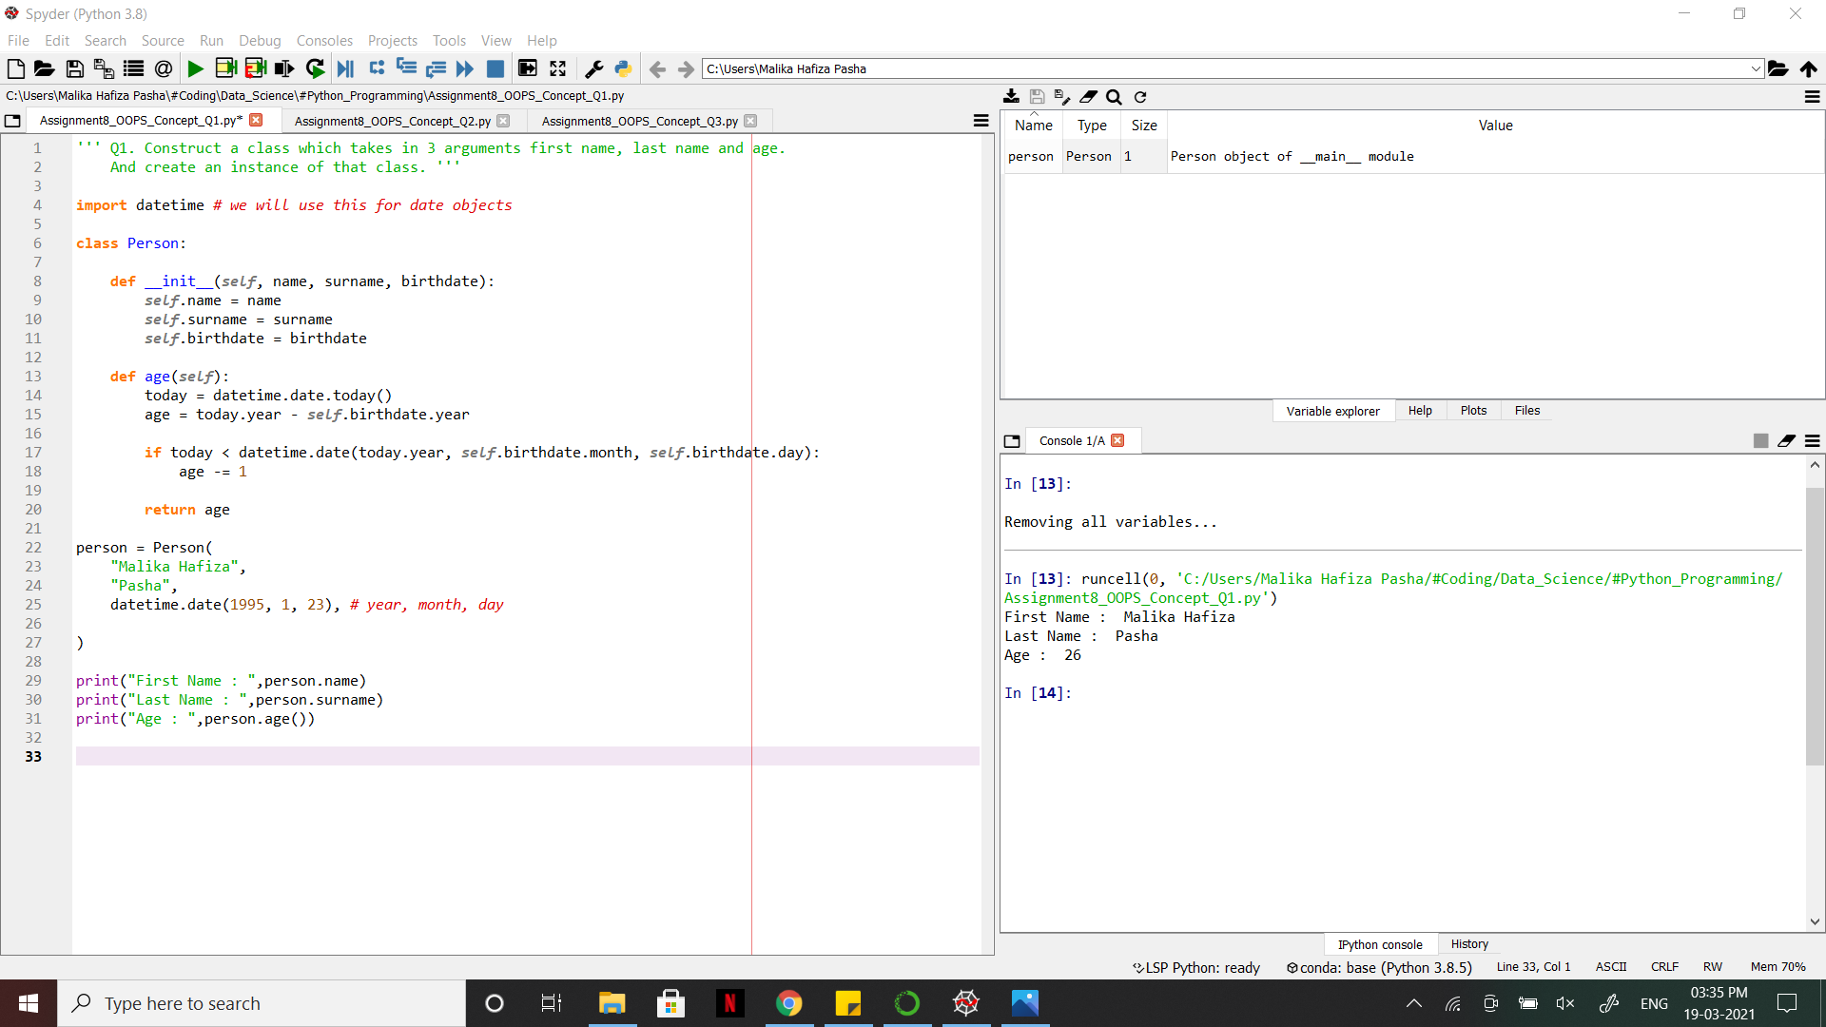

1. Construct an example for Inheritance.

**Answer:** [Python file is attached with the assignment file]

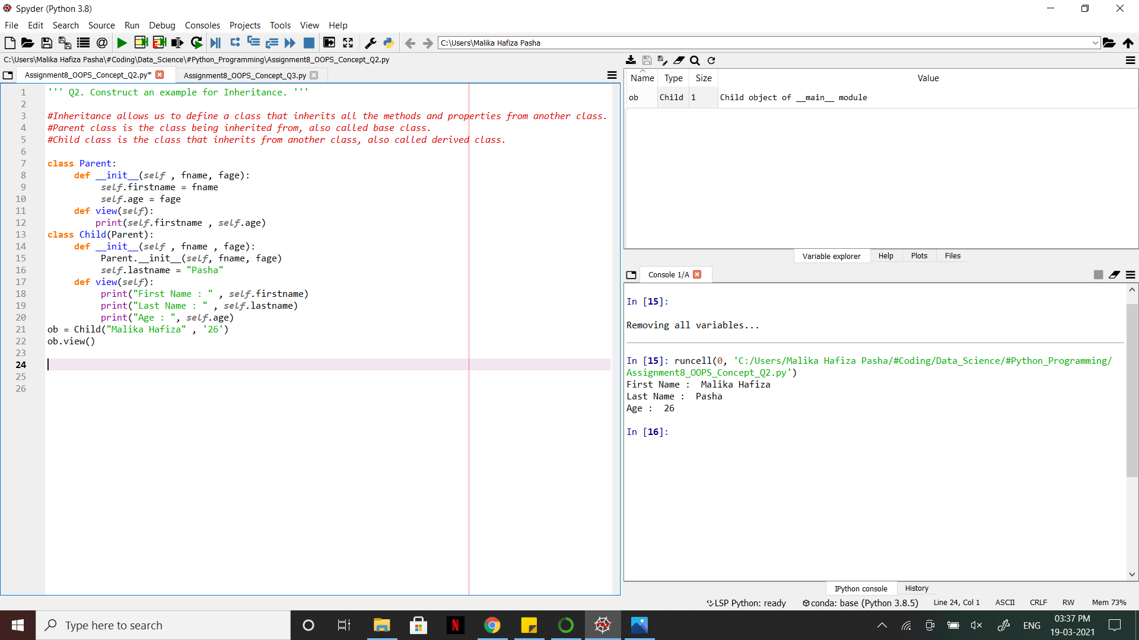

1. Explain Polymorphism in Python? Construct an example for Polymorphism.

**Answer:** [Python file is attached with the assignment file]

POLYMORPHISM:

* Polymorphism means the ability to take various forms.
* It is the ability of an object to adapt the code to the type of the data it is processing.
* It is a built-in feature.
* Polymorphism allows to define methods in the child class with the same name as defined in their parent class.
* Polymorphism means same function name (but different signatures) being uses for different types., (i.e.) it helps to describe an action regardless of the type of objects.

